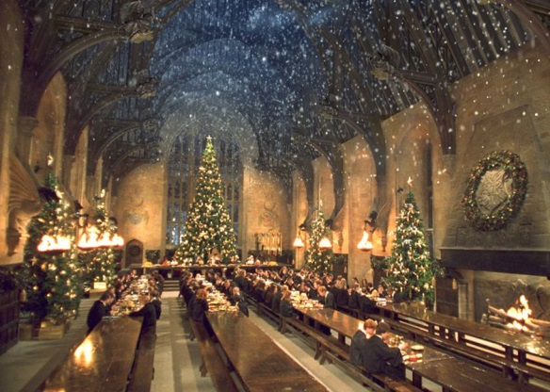
The Hogwarts Gang have Christmas Shopping!
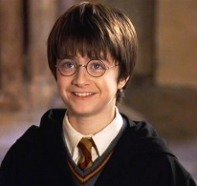
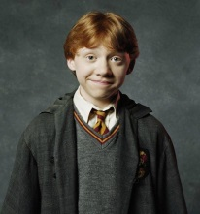
- Harry has £84.63. He spends £7.42 on a new broom for Ron. How much does he have left?
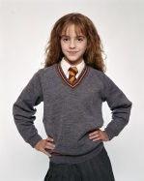
- Ron has £57.24. He spends £8.93 on a new cage for his rat. How much does he have left?
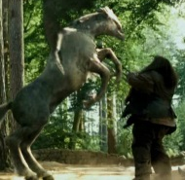
- Hermione has £62.49. She spends £2.67 on a new cauldron for her potions class. How much does she have left?
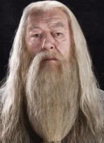
- Hagrid has £75.60. He spends £9.29 on ferret food for Buckbeak. How much does he have left?
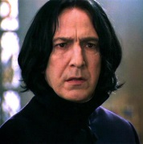
- Dumbledore has £67.46. He spends £4.30 on Christmas decorations for Hogwarts. How much does he have left?
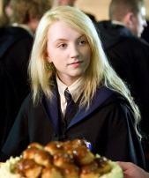
- Professor Snape has £89.28. He spends £8.14 on a dark spells book. How much does he have left?
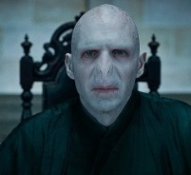
- Luna has £28.67. She spends £2.10 on Christmas socks. How much does he have left?
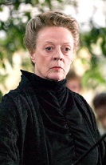
- Voldemort has £79.84. He spends £6.78 on a new Horcrux. How much does he have left?
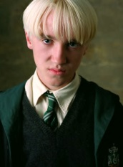
- Professor Mcgonagall has £87.75. She spends £7.40 on a new wand. How much does she have left?
- Draco has £27.63. He spends £2.31 on blonde hair dye. How much does he have left?

