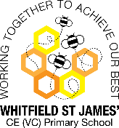

WHITFIELD ST JAMES’ CE (VC) PRIMARY SCHOOL___________

Dear Parents and Carers,

This year we're embracing the 'Bring A Stick To School Day' as part of an initiative created by The Muddy Puddle Teacher www.themuddypuddleteacher.co.uk

'Bring A Stick To School Day' is as simple as it sounds. We will ask all children to go for a walk at home, find a stick and bring it into school on Thursday 7th October 2021.

The day aims to draw attention to the joys of play and how simple items, such as a used stick from a tree, can be anything if we imagine it to be. It could be a stick, it could be a dragon, it could be a unicorn - it could even be a magic wand!

We will also be drawing the children's attention to nature and how the small, natural friend they’ll be clutching all day has come from a tree. We’ll also consider how we can look after our trees and connect a little more with all things natural.

We will be doing lots of fun activities throughout the day and will take lots of photographs to share with you.

Please note, we will be talking to children about stick safety. To help embed the same methods, try watching this fun and animated video - https://www.youtube.com/watch?v=OpLVs4k5Xf0

Thank you for your support

Mrs Cox and Mrs Thornley
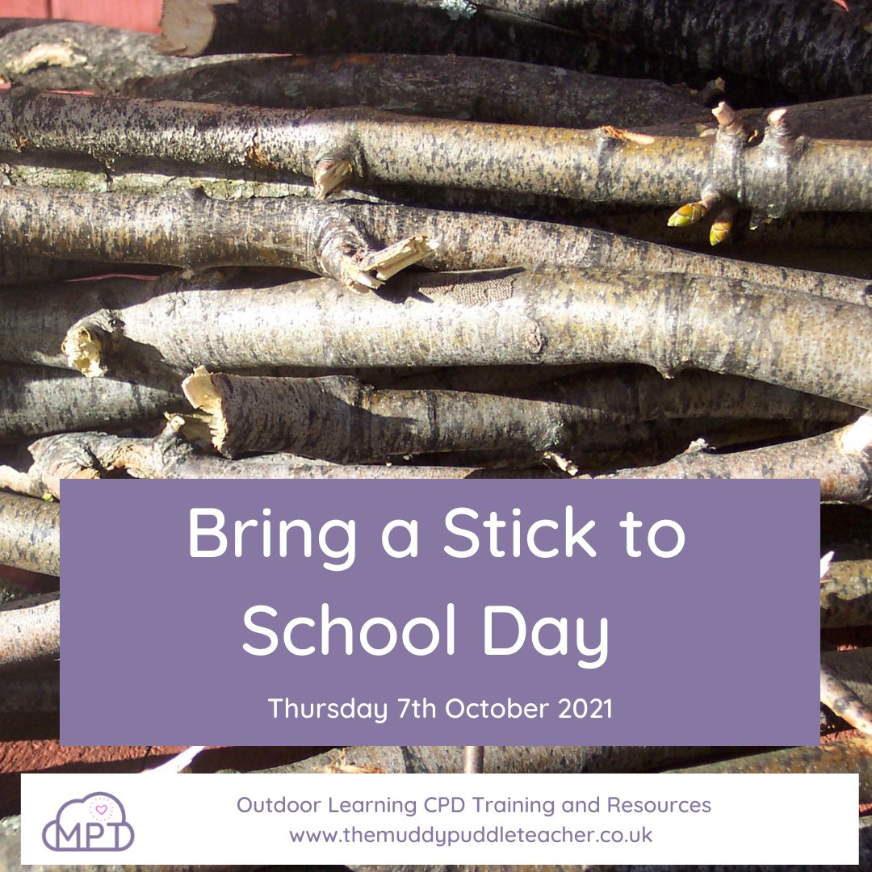
Important!
Choose a stick no longer than your arm and
no thicker than your wrist!

